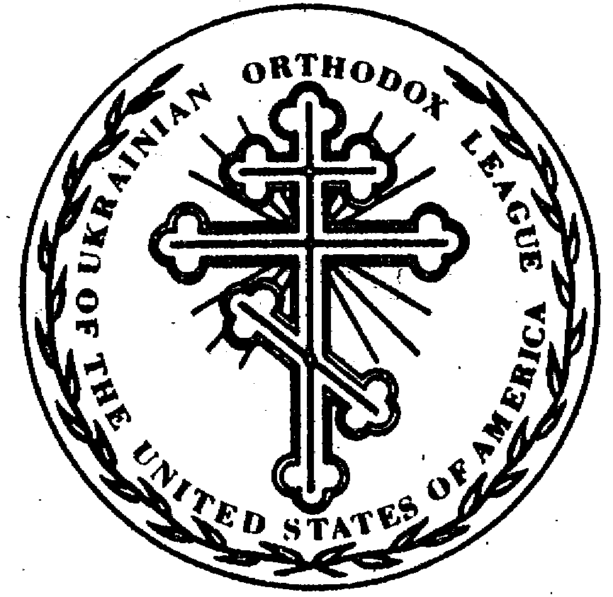
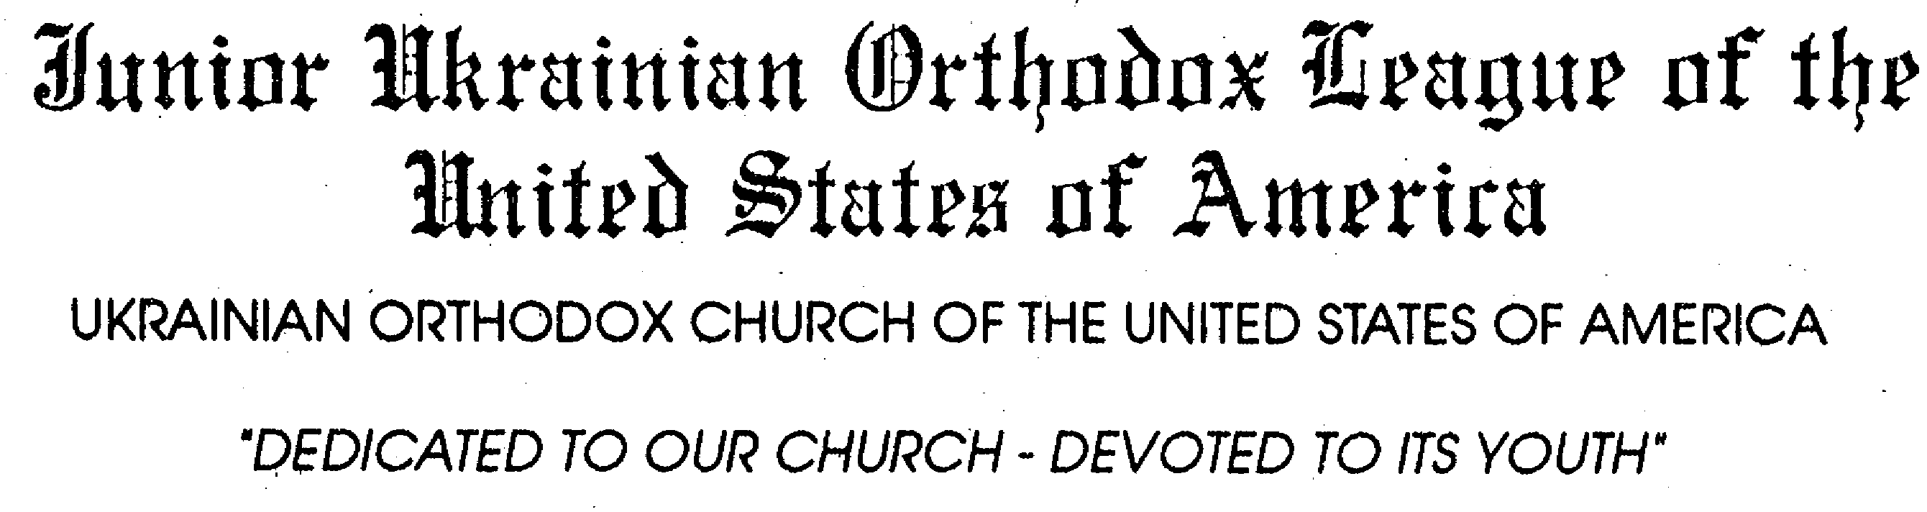

OREST MAHLAY, PRESIDENT 2016-2017
juniorPres@uol.orthodoxws.com

SPIRITUAL ADVISOR
V. Rev. John Haluszczak
Report to the 21st Regular Sobor of the UOC of USA
October 19, 2016

Glory to Jesus Christ! Слава Ісусу Христу!
The Junior Ukrainian Orthodox League is an organization of our Ukrainian Orthodox Church, which promotes and supports the youth of our Church in spiritual growth and development. Our main purpose is to serve God and others, to promote fellowship and to prepare to be future leaders of the church. The Junior motto, “Faith, Fellowship, and Fun” sums up our purpose and communicates our focus on youth involvement. The League’s motto “Dedicated to Our Church - Devoted to Its Youth” points to the fact that our work is done to assist our youth.

CHAPTERS AND MEMBERSHIP
- 10-18 years old
- 10 Chapters (Located in PA, NY, NJ, RI, MA, OH, IL)
- 5 Members required for a chapter
- Members outside of an existing chapter become Members-At-Large

CONVENTIONS
The Junior League holds its Annual Convention in conjunction with the Senior League. We have our own business sessions, and formulate plans and objectives in our own committees. Each committee is headed by a member of the Executive Board. Their job is to make sure these committees do what they are supposed to do to keep the Junior UOL running smoothly. At convention, the delegates formulate goals, expectations, and try to set the direction of the programs for the year.

juniorSPAD@uol.orthodoxws.com
ADVISOR
Taylor Gladys
juniorLAD@uol.orthodoxws.com
VICE PRESIDENT
Erica Holowko
juniorVP@uol.orthodoxws.com

RECORDING/CORRESPONDING
SECRETARY
Alexis Naumenko
juniorRecSec@uol.orthodoxws.com

FINANCIAL SECRETARY
Sophia Dobronos
juniorFinSec@uol.orthodoxws.com

TREASURER
Cyril Sheptak
juniorTreas@uol.orthodoxws.com

JUNIOR PROJECTS/COMMITTEES

Christian Care Giving and Missions:
The Christian Care Giving and Missions Committee was established to initiate service projects and missions to spread the word of Christ from the Juniors to others around the world. The main projects that the Junior UOL supports through the Christian Care Giving Committee are the Thanksgiving Tithing Project and “Souper Bowl” Sunday Fundraiser which are conducted in conjunction with the Senior UOL and The Great Lent Giveaway which is a combined project with the UOC of USA Office of Youth and Young Adult Ministry.

In the recent past, the Thanksgiving Tithing project benefited growing mission parishes all over the country, but recently both Junior and Senior UOL have changed the Thanksgiving Tithing to be a project that is done by individual chapters in their area, making it more local and personal. The “Souper Bowl” Sunday benefits the Saint Andrew’s Society and their Christian outreach programs of soup kitchens in Ukraine.

Each year, the Great Lent Giveaway benefits a different charity. In 2014, the theme was “Focus on Giving” which benefited the FOCUS North America. The Junior League donated $2,650 and over 500 pairs of socks for this cause. In 2015 the theme was “Blessed Are the Peacemakers”: the Junior League raised over $1,100 for the Aid to Ukraine Relief Fund that the Ukrainian Orthodox Church initiated. This past year, the beneficiary was the Saint Jude Children's Research Hospital, and the Junior UOL raised over $1,500. The Great Lent Giveaway is not only a fundraiser for a specific charity; through the church school programs developed by the Office of Youth and Young Adult Ministry, it is a way for all of us, as Juniors, to learn more about our faith in the context of each year’s theme.

Pysh Travel Grant:
One of the long standing funds of the Junior Ukrainian Orthodox League is the Pysh Travel Grant. Several years ago, Mr. Wasyl Pysh generously donated $10,000 to the Junior League to help pay for travel to the convention for junior delegates. The Pysh Travel Grant has helped many new Jr. UOL members with the costs of travel to convention enabling them to become more active.

Membership and Chapter Development and Connecting the Church:
The Membership and Chapter Development Committee is responsible in ensuring the future of the Junior Ukrainian Orthodox League. This committee is centered on encouraging others to join the Jr. UOL and keeping in contact with existing chapters. The committee chair is responsible for contacting parishes around the country to see if any are interested in being a part of the League.

Technological Advancements:
This Committee has grown in importance during the past three years. We utilize the website available to us through the Senior UOL. Our website consists of contact information, UOL merchandise, documents available to be printed, and other important information about upcoming events in the UOL. The Junior UOL has also been promoting events on their Facebook group as well as on the official UOL Facebook page. The Junior UOL has also worked alongside the official UOC of USA social media to promote events, activities and initiatives.

Cultural and Education:
This committee works on maintaining Ukrainian culture as well as educating members during the year. This past year, the Junior UOL helped in organizing and encouraging youth to come to the Holodomor Commemoration in Washington, DC for the installation of the new monument. This committee also encourages participation in the Annual Essay Contest, which is managed by the Senior UOL. Finally, this committee encourages others to write for the UOL Bulletin that comes out regularly during the year. This helps members to stay updated and informed about the Junior UOL.

Fundraising:
This committee focuses on ways the Junior Ukrainian Orthodox League can raise revenues. We have recently started to compile a fundraising pamphlet to send out to the chapters sharing new and exciting ways to support our projects. Our large fundraiser over the last couple years was our UOL sweatshirts that we created. We were able to sell all that we made and hopefully this year we can try another merchandise item to sell. The Junior Ukrainian Orthodox League’s biggest national fundraiser is the Annual Raffle which is sold from May until the Banquet and Ball at Convention.

AWARDS
Every year, the Junior Ukrainian Orthodox League gives out two awards at the Annual Convention. The Chapter Achievement Award is presented to the Junior Chapter that has shown the greatest achievement in terms of accomplishing the aims and purposes of the UOL during a one year period of time. The recent winner of the Chapter Achievement Award was Saints Peter and Paul Chapter of Youngstown, Ohio. The Very Reverend Volodymyr Bukata Award is given to the Junior member who has done outstanding work toward accomplishing the goals and aims of the UOL on a national, regional, parish or chapter level. The most recent winner of the Father Bukata Award was Nicholas Woloschak from Youngstown Ohio. In the past two years we have not had applications that merited the award.

ADVISORS
The National Executive Board and every chapter are appointed a spiritual advisor and a Senior UOL advisor. We rely on the clergy of our church and the Senior UOL to encourage participation, commitment, excitement and prayers for the Junior Ukrainian Orthodox League throughout the year. The Junior UOL is extremely grateful for their continual love, support, guidance and prayers. We would like to thank our past Senior Advisors, Daria Pishko-Komichak and Tabitha Bentley, as well as our past Spiritual Advisor, Rev. Father Vasyl Sendeha, for their work. We also extend a special thanks to our present advisors, Taylor Gladys and V. Rev. Father John Haluszczak; also to His Eminence Metropolitan Antony and His Grace Bishop Daniel for their continual support and guidance.

POSITIVE OUTCOMES:
- Connected the youth of our parishes throughout the country
- Tithed to the Ukrainian Orthodox Church of the USA in the 2015-2016 year
- Raised money for Make-A-Wish Foundation, FOCUS North America, St. Andrew Society, Aid to Ukraine Relief Fund, St. Jude Children's Research Hospital
- Completed four year pledge of $4000 to All Saints Camp S.O.S. Program
- Able to send members to Convention with Pysh Travel Grant Fund
- Giving out scholarships to campers at All Saints Camp
- Gained a new chapter - Sharon, PA
- Funded the Icon that was dedicated to our Youth Ministry

CHALLENGES:
- Loss of chapters due to lack of interest, commitment or loss of kids from ages 10-18
- Communication problems
- Not being able to reach out to new parishes
- Reinvigorating the Ukrainian Orthodox League to address challenges in the present day - in contrast to the status quo that has outlived itself

THOUGHTS:
The Junior Ukrainian Orthodox League is an important organization in the UOC of USA which can promote parish involvement of youth from the ages of 10-18. The Junior UOL can become more successful if presented and promoted properly to all parish clergy, faithful and youth. The future can be quite promising if board members and individual chapters continue to be motivated about youth activities. The Junior UOL faces challenges ahead as it pursues to become an organization at more of our parishes. Some changes that may lay ahead for the Juniors are changes to the Convention format, more engaging social media and communication (in collaboration with the Senior UOL), and becoming a leader in addressing today’s challenges of the youth as well as in our Church.

Respectfully Submitted,

Orest Mahlay
Junior Ukrainian Orthodox League President

